John Collin FRCSEd (OMFS)

Specialist Trainee in Oral and Maxillofacial Surgery, Severn Deanery.

Head and Neck Oncologic and Microvascular Reconstructive Fellowship, University of Florida, Jacksonville. 01/07/19 – 30/06/20.

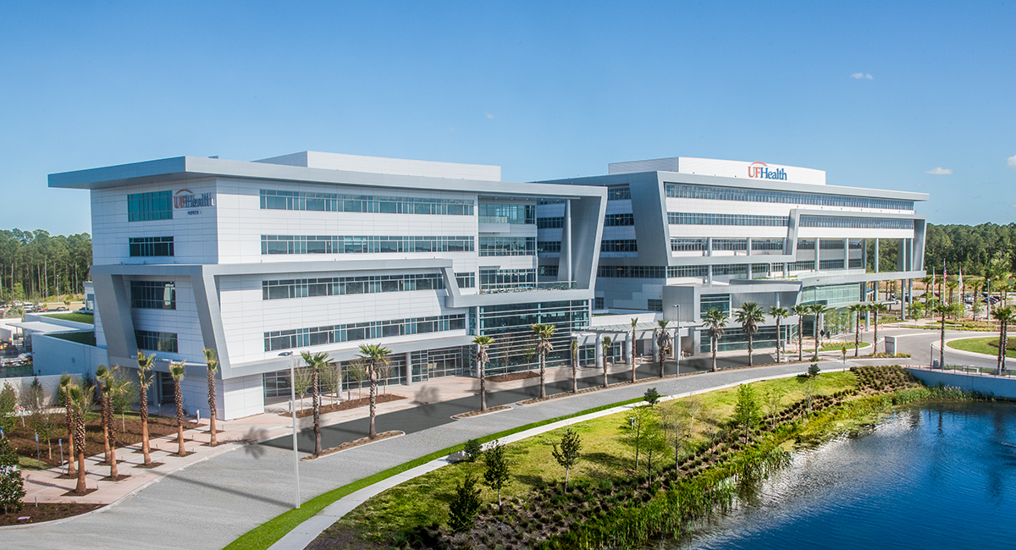
Figure 1. University of Florida Health Jacksonville North Campus.

Early in my specialist training I knew that I wished to sub-specialise in head and neck oncology and reconstruction. I therefore researched which centres might offer the best fellowships world-wide. Whilst there are excellent head and neck fellowships in the UK, I was also keen to experience healthcare and surgery in another country. I was fortunate to be awarded the University of Florida Fellowship via the US Maxillofacial Oncology and Reconstructive Surgery matching scheme, after having visited the department to meet with the Fellowship Director, Dr. Rui Fernandes and the Head of Department, Dr. Tirbod Fattahi. The process of obtaining visas, a medical licence, accommodation and transport was difficult and expensive, so the award of a BAOMS grant was very gratefully received.

On arrival in Jacksonville, I was immediately made to feel most welcome by the entire department. I was very impressed by the common sense of purpose, organisation and work ethic that made the team highly regarded within the hospital. The academic ambition of the Faculty and the teaching program for Residents across the full remit of OMFS was excellent, with frequent visits from highly regarded international speakers. The range of head and neck surgery that I performed with Dr. Fernandes and Assistant Professor, Dr. Anthony Bunnell was far broader than that seen in most OMFS units.

The majority of patients presented for resection and reconstruction of oral cavity, pharyngeal and laryngeal tumors (Figures 3&4). Thyroid, parathyroid, salivary gland and skin malignancy surgery made up a large proportion of the remainder. In addition, the OMFS service provided surgical airway and cranial/cervical spine access for the hospital as well as soft tissue reconstruction for limb trauma. In terms of volume, typically 3-3.5 days per week were spent in the operating room, and it was not uncommon for there to be 3 or 4 ORs running simultaneously on these days.

I received excellent technical training in head and neck reconstruction using the full-range of local, regional and free flaps. Attention to detail, ensuring minimal blood loss and efficiency of operating was emphasised. Experience with procedures at the periphery of the traditional OMFS remit, such as laryngectomy, facial reanimation, skull base and occuloplastic surgery afforded a more holistic approach to the management of head and neck patients. Most major reconstructive surgery was planned virtually to produce custom guides and implants. Where possible, minimal access and transoral approaches were employed and immediate placement of endosseous dental implants undertaken.

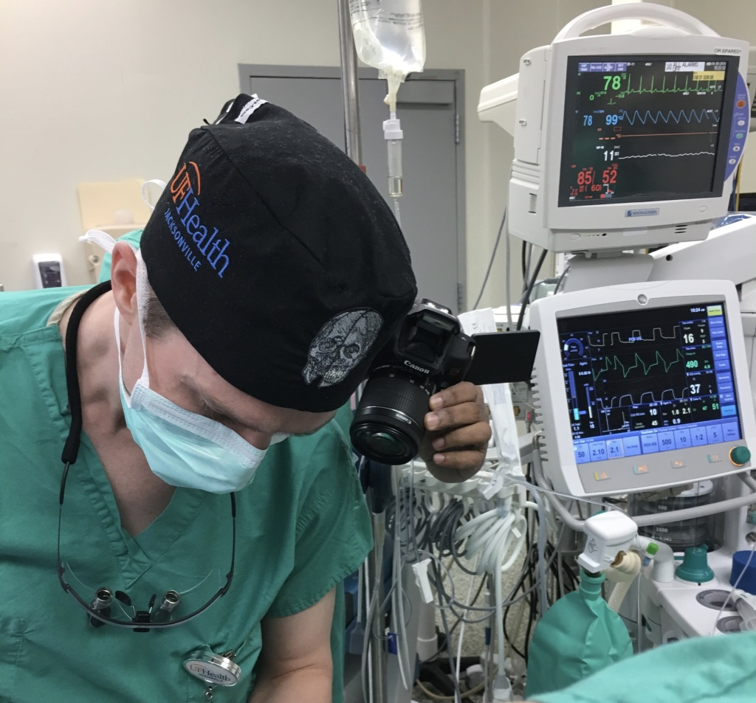
Figure 2. Close supervision by Dr. Fernandes during tracer injection prior to sentinel lymph node biopsy.
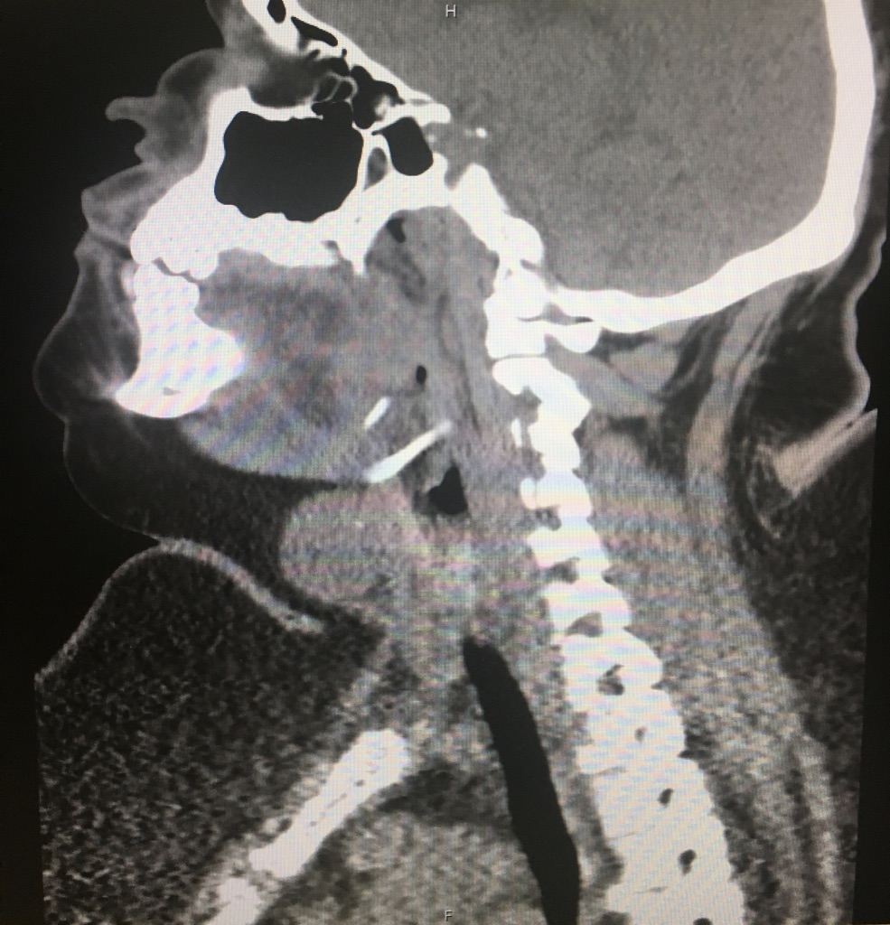
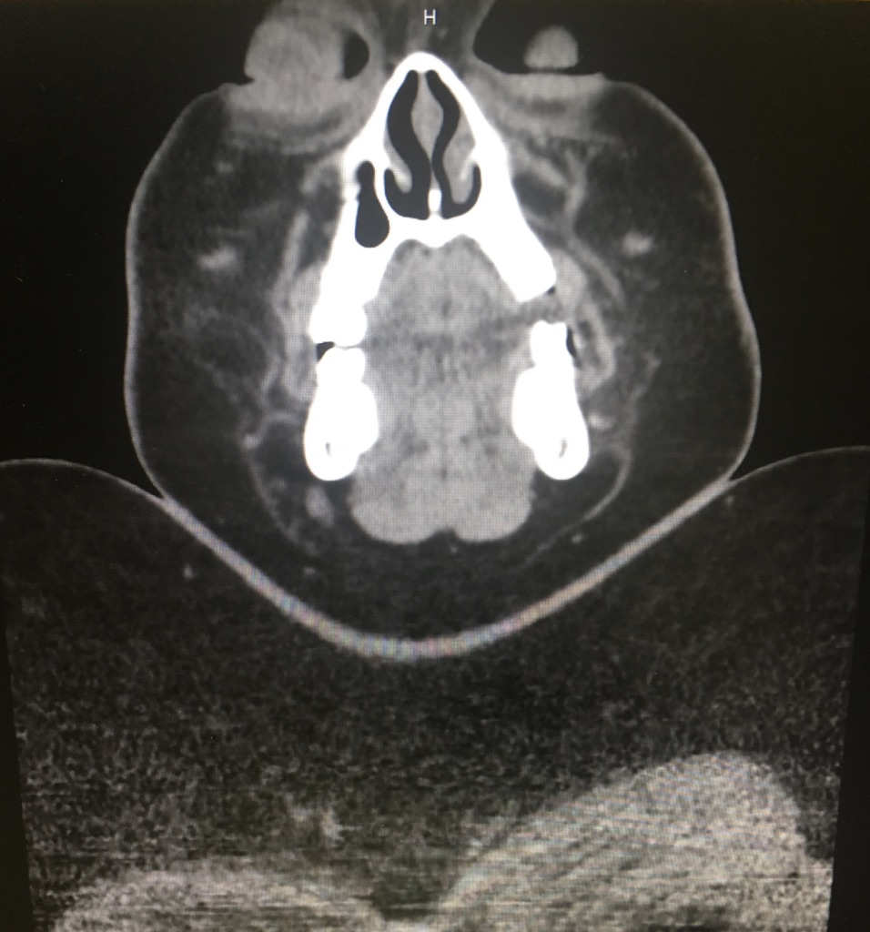
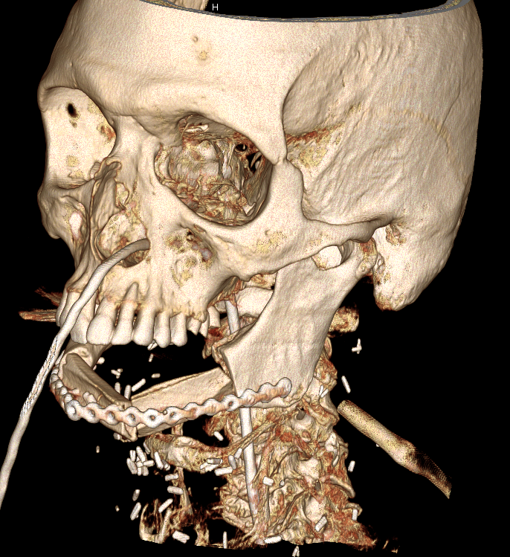
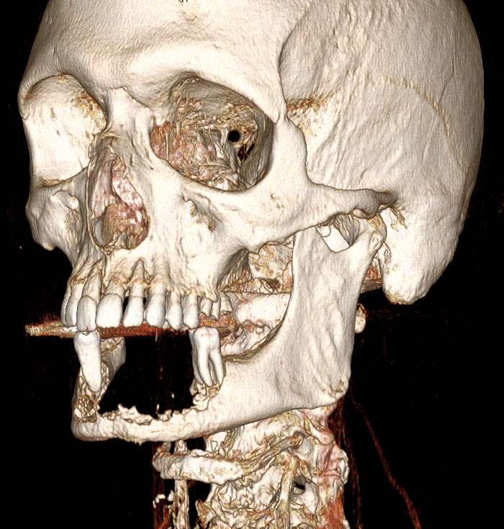
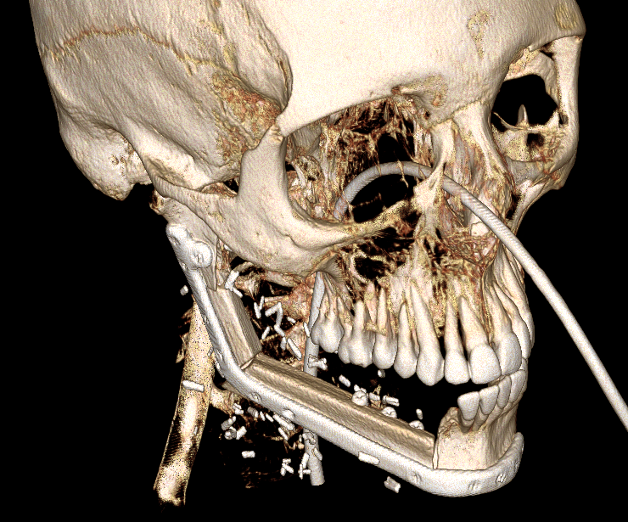
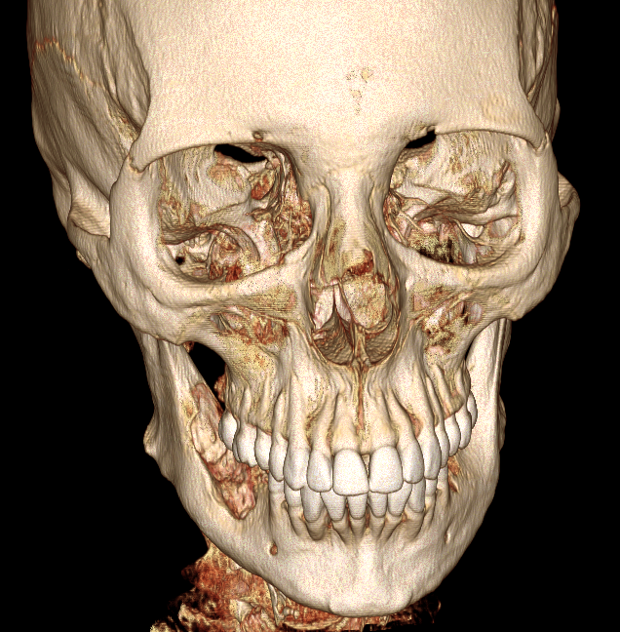
Figure 5. Pre-operative CT for metastatic papillary thyroid carcinoma demonstrating challenging body habitus for total thyroidectomy and neck dissection.
Figure 4. 3D CT demonstrating advanced oral squamous cell carcinoma eroding the anterior mandible (left) and post resection, with chimeric composite scapula and latissimus dorsi free flap to reconstruct mandible, anterior floor of mouth, lip and chin (right).
Figure 3. 3D CT showing ameloblastoma of right mandibular body and ramus (left) and post resection with 2-piece fibular free flap reconstruction and immediate endosseous implants for dental rehabilitation (right). The resection and reconstruction was performed transorally.
Due to the reputation of Dr. Fernandes and the Head and Neck Oncology team at the UF Proton Institute, patients would often travel from out of state and occasionally internationally for treatment. This meant exposure to unusual pathology. Many patients presented late with advanced disease due to lack of insurance coverage and some because they had received inappropriate treatment elsewhere or had spent time ‘shopping around’ various institutions. High levels of gun ownership also meant that facial gunshot wounds were commonplace. Around one third of American adults are obese and this is associated with a number of health risks particularly in the peri-operative setting. Morbidly obese patients presented a challenge for surgical procedures that would otherwise be straightforward (Figure 5). The culture of US healthcare is even more disparate than I had anticipated, and a lot of time was spent on defensive practice and billing activities. Having to see patients develop inoperable tumors due to lack of insurance and even those with insurance having significant delays and queries over funding has given me a renewed appreciation of the National Health Service.

This fellowship has given me invaluable experience in the management of head and neck oncology patients. I now feel competent in a wide range of reconstructive procedures, and my surgical technique has improved greatly both in terms of precision and expediency. I am sure my future patients in the UK will benefit from this.

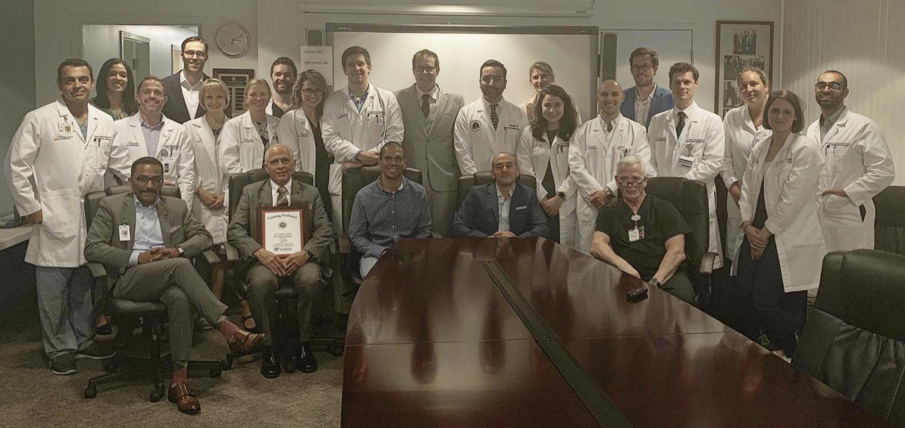
I am very grateful to Dr. Fernandes and his colleagues for allowing me to care for and operate on their patients and for providing excellent training in both surgical and non-surgical skills. The Faculty’s support of international fellows at UF Health is to be commended in the face of increasing difficulties in securing visas and medical licensure. I also wish to thank my trainers in the UK, Dr. Ceri Hughes and Prof. Steven Thomas for their mentorship and encouragement with pursuing an international fellowship. Most importantly, I would not have been able to undertake this fellowship without the support of my wife who agreed to take time out from her career, travel with me and give birth to an American baby (Figure 7); fortunately our employee health insurance covered the $26 000 bill for a routine delivery.
Figure 6. The UF Health Jacksonville OMFS department with visiting Professor Dr. Rodolfo Asensio.

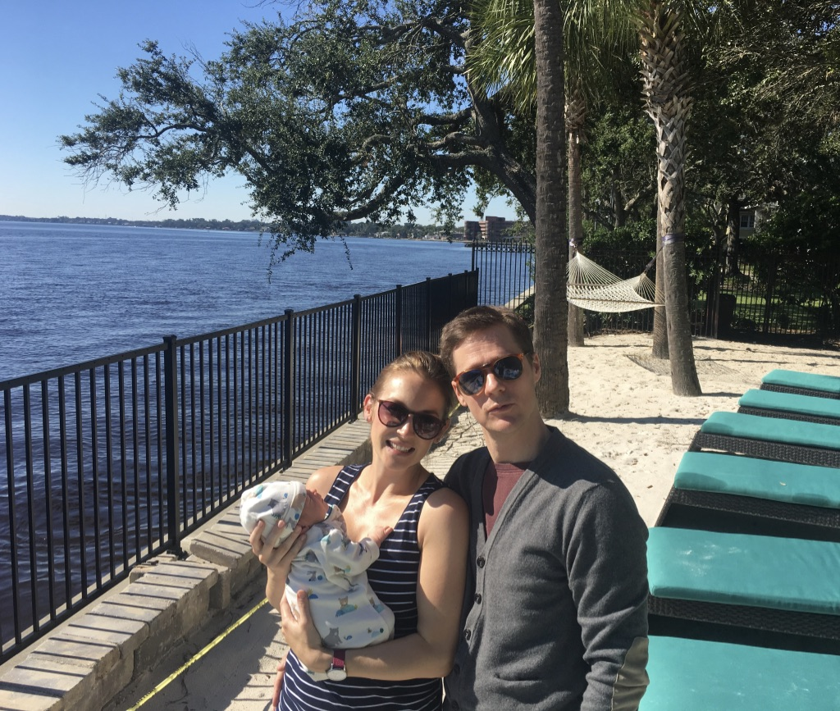
.
Figure 7. At home with the 26k dollar baby.

